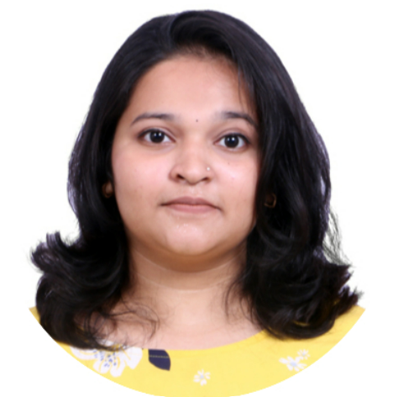

Hitika Bhandari

Programmer Analyst Trainee

[hitika.bhandari@cognizant.com](mailto:hitika.bhandari@cognizant.com)

8369099867  
**Summary_________________________________________________**

Achieve a position in the organisation where I can use my skills in an effective manner and achieve personal as well as organizational goals.

**Areas of Expertise Industries**

* Java Cognizant
* SQL
* SAP

**Work Experience___________________________________________**



**Role/Work title**

**Programmer Analyst Trainee**

**Winchester (WIN) STPI** Currently undergoing a training program on SQL, Java and SAP

including query writing, Problem solving and Data analysis.

Gaining technical knowledge and improving my programming

skills. Learning and developing my skills in SAP using SAP tool.

**Education_________________________________________________**

**Graduation: Shah & Anchor Kutchhi Engineering College**

B.E (2019-2022)

**Intermediate: Shah & anchor Kutchhi Polytechnic**

IT (2016-2019)

**Language_____________________Skills________________________**

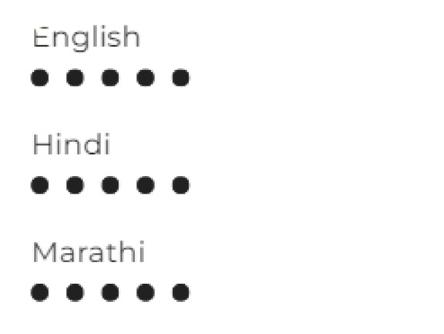 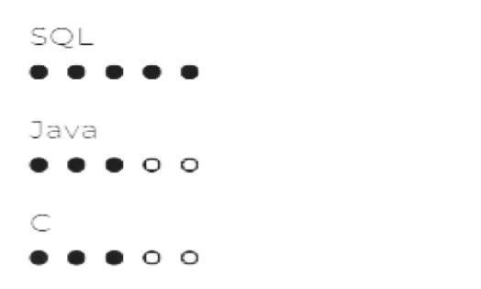

**Extracurricular Achievements________________________________**

* Participated in Technical Paper Presentation for project “Autism Xpress” in Terna Engineering College.
* Participated and won 1st prize in Technical Paper Presentation in Thakur Polytechnic for project “Autism Xpress”.
* Participated and won 1st prize in Online Project competition for project “Gallery Image Classifier” in Shah and Anchor Kutchhi Engineering college
* Participated in the Inter-College Coding Competition: Semi code held in February 2019.
* Went to attend 1 day camp at Bhabha Atomic Research Centre, Mumbai for National Science Day-2017
* Participated in Wall Painting under "Swachhta Pakhwada" held in September 2017.
* Participated in All India Essay Writing Event held in 2017.
* Was a part of SAKEC Newsletter editorial Team “Technorithm 2021”.